Hello professor this my answer for Homework 2

The kinetic energy of an item having a mass of 1.0 kg and a velocity of 4.0 m/s is larger.

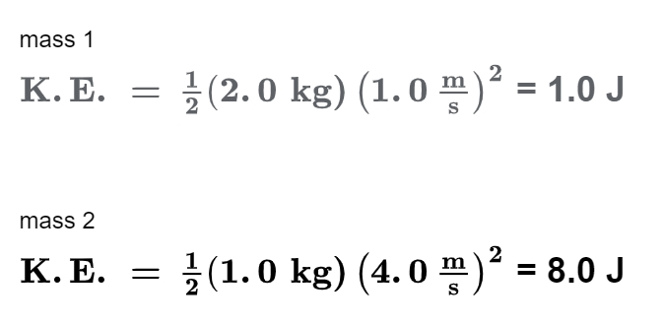

Student ID : 201923250

Name : Kobilov Ilkhomjon